Life skills for little ones – Starting School or Nursery

Is your child starting school or nursery this September?

In Hertfordshire libraries you can find lots of picture books that can prepare your little ones for this big change and will help dispel any worries or fears they may have. Here is a selection of some of our favourites.
You can request books free of charge with a child’s library membership card. Click on the book cover pictures to link to the Hertfordshire library catalogue or visit www.hertfordshire.gov.uk/libraries

Also why not also keep them busy and join in with ‘Wild World Heroes’ this year’s Summer Reading Challenge a fun way to encourage the love of reading and sharing books together.

Title | Author |  | Brief annotation
Starting school | Janet and Allan Ahlberg | 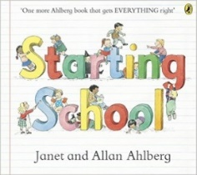 | From first day nerves to finding your peg, this reassuring read is full of humour and fun for children and parents alike. A classic picture book which offers advice and enjoyment for the whole family before school starts.
Topsy and Tim start school | Jean Adamson and Gareth Adamson | 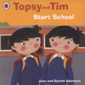 | Along with favourite characters Topsy and Tim, children will learn what to expect in lessons, in the playground - even in the canteen - and, more importantly, that school can be fun!
George’s first day at playgroup | Neville Astley and Mark Baker | 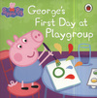 | It is George's first day at playgroup, and Peppa doesn't really want him there. But when all of her friends want a little brother too, will Peppa change her mind?
I am too absolutely small for school | Lauren Child | 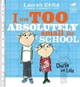 | Lola is nearly big enough to go to school. But in her opinion she is still really quite small, and has far too many important things to keep her extremely busy at home.
Going to School | Anne Civardi | 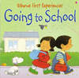 | One of the 'Usborne First Experiences' series, “Going to School” uses simple text to introduce very young children, in an amusing and friendly way, to a new situation.
Come to school too, Blue Kangaroo | Emma Chichester Clark | 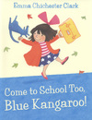 | Lily thinks Blue Kangaroo might be nervous about starting school – but in fact he can’t wait to have fun and make some new friends.
Maisy goes to Nursery | Lucy Cousins | 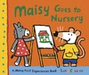 | Maisy loves going to nursery. There's so much fun to be had, with all her friends and their teacher - singing at music time, a nap at quiet time, listening at book time and then play time in the garden. What a day.
Little Owl’s first day | Debi Gliori and Alison Brown | 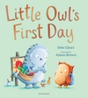 | It’s a big day for little Owl, his first day at school. He would rather stay at home, however at school he gets to build a rocket learn to fly and even make a new friend.
Spot loves Nursery | Eric Hill | 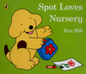 | Join Spot in a story all about his first day at nursery school. There are lots of friends to meet and fun things to do before Mum comes to pick Spot up at the end of the day
Do I have to go to school- A first look at starting school | Pat Thomas | 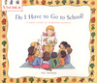 | Going to school is a huge change for young children, this book encourages children to discover the joy of learning new things, meeting new people and having new experiences.
Chu’s first day at school | Neil Gaiman and Adam Rex | 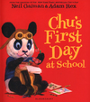 | Chu is a little panda with a BIG sneeze and when his first day at school approaches, he is nervous. Will the other boys and girls be nice? Will they like Chu?
Hugless Douglas goes to Little school | David Melling | 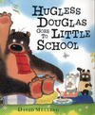 | Hugless Douglas is very excited to be going to Little school. There is so much to do.
Whiffy Wilson the wolf who wouldn’t go to school | Caryl Hart and Leonie Lord | 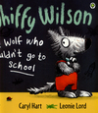 | Whiffy doesn’t know how to hold a pen and has never looked in a book, but fortunately his friend Dotty is on hand to show him that school is fun. Banish first day at school jitters and discover, like Whiffy, that school is the best thing ever.
First day at Bug school | Sam Lloyd | 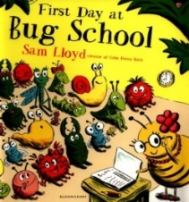 | At the bottom of the garden where no one really sees, a secret school is hidden amongst the grass and weeds. Welcome to the bug school. A bright and rhythmic picture book sure to allay first-day-at-school fears.
Harry and the dinosaurs go to school | Ian Whybrow and Adrian Reynolds | 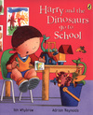 | It is the first day at school for Harry and his bucketful of dinosaurs and they're excited to be going - all except Stegosaurus who's very nervous.
Lulu’s first day | Anna McQuinn | 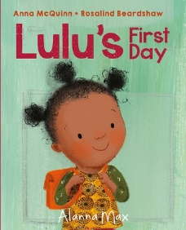 | Lulu is excited to start pre-school. It will be like storytime at the library, but she will stay by herself. There's so much to do at pre-school and in no time at all, Mummy is back to collect her.
My school unicorn | Willow Evans and Tom knight | 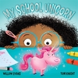 | Starting school is an adventure - especially when you have a magical unicorn friend by your side! Evie soon learns that starting school is LOTS of fun!
Never take a bear to school | Mark Sperring and Britta Teckentrup | 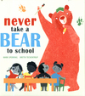 | Bears are clumsy. They don't sit still. They're much, much bigger than teachers - and they eat SUCH a lot of lunch! Yes, taking a bear to school is a BAD idea. But will this little boy find the courage to face the first day of school alone?
All the words you need to know before you start school | Felicity Brooks | 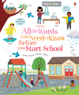 | Help pre-schoolers build the vocabulary they will need to communicate effectively, make friends, and learn to read and write when they start school.
  www.hertfordshire.gov.uk/libraries |  | 

