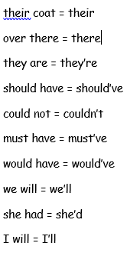
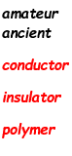
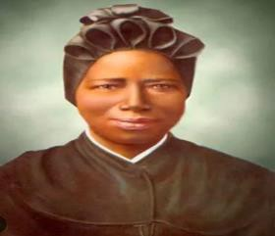
2
Spellings:
To be tested on Thursday 19th September
(Rule- there, their, they’re and contractions PLUS statutory words and Science words)
Year 5 St. Bakhita
Autumn 1
Week 1
Art
We investigated and collected visual information from Hundertwasser images and we created a fact page about Hundertwasser.
PSHE
Know what I value most about my school and
can identify my hopes for this school year
Homework

Times Tables Rock Stars
Atom Learning Boom Reader Spellings

Homework to be well presented, neat and it should be evident that an appropriate amount of time has been spent on it so it can be completed to a high standard.
RE Homework for this term:

PE
Basketball and Tag Rugby
History Ancient Egypt
We have been learning about the concept of a civilisation.
Science
Exploring the process of sieving and learning how to draw and annotate a diagram to explain a concept.
Please could the children bring in plastic bottles for Tuesday!
Gold Book!
Cecilia
Fantastic contributions to English and all lessons
R.E
This week in RE, we have been learning about, Moses, his journey through Egypt, the burning bush and sequencing his time through Egypt until he reaches mount Sanai.
Catholic Social Teaching- Care of Creation
Maths
-Roman numerals to 1,000
- Numbers to 10,000
- Numbers to 100,000
- Numbers to 1,000,000
English
Text: ‘My Baba’s Garden’
Inspired by our new text, we had fantastic and enriching conversations about the writing style, characters and emotional connections.
We have been recapping/learning some key grammar skills:
‘’ Punctuation, Expanded Noun Phrase, Conjunctions ‘’
For our Star Write, we put all of these into practice and wrote a book review.
Handwriting Hero- Jack
Star Writer- Cecilia

