Bank of Home Learning Resources for Mathematics
What resource is the school providing for maths homework?
Times Table Rockstars is now our primary homework focus. We expect children from Year 2 and above to be playing Times Table Rockstars at least 4 days per week. Times tables are a huge focus in the National Curriculum and all times tables (out of order and within 5 seconds) are expected to be learnt by Year 4. Fluency, speed and recall are focused upon in Years 5 and 6.
What other maths homework is my child expected to do?
Choose one or more of the resources below, and revise the maths skill or concept that your child has been learning in class each week.
How will I know what my child has been learning about?
Each Friday, in the School’s newsletter, you will be notified what your child has been focusing on in class that week. Please note that some learning sequences may last longer than a week, meaning the homework focus may remain the same.
Who will monitor my child’s homework?
Teachers will monitor whether your child is accessing Times Table Rockstars regularly. Parents/carers will be expected to sign their child’s homework diary to evidence the use of other websites/apps/workbooks.
Some useful websites:
Oxford Owl | https://www.oxfordowl.co.uk  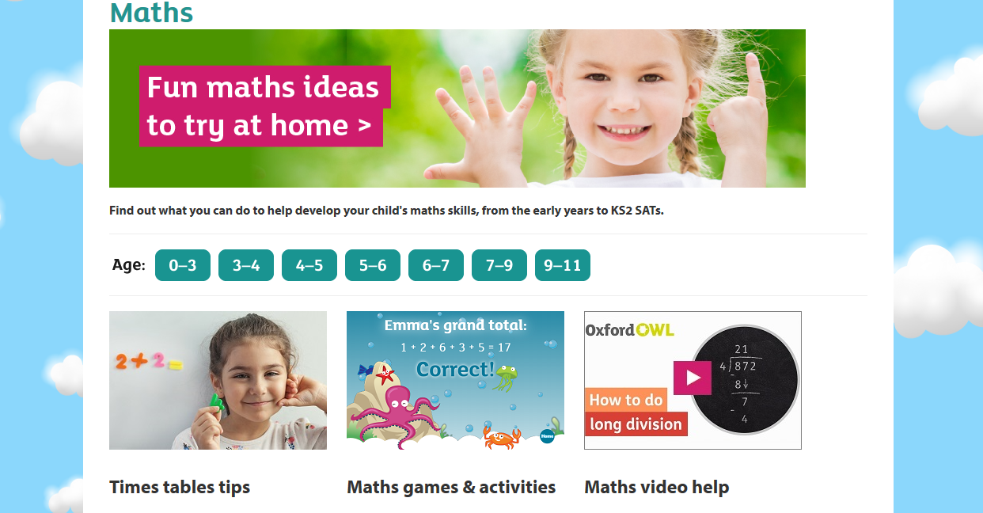 | The maths section on Oxford Owl has lots of activities for every year group.  There are also tutorials that support parents/carers in learning about new methods and strategies taught in schools.
IXL | https://uk.ixl.com  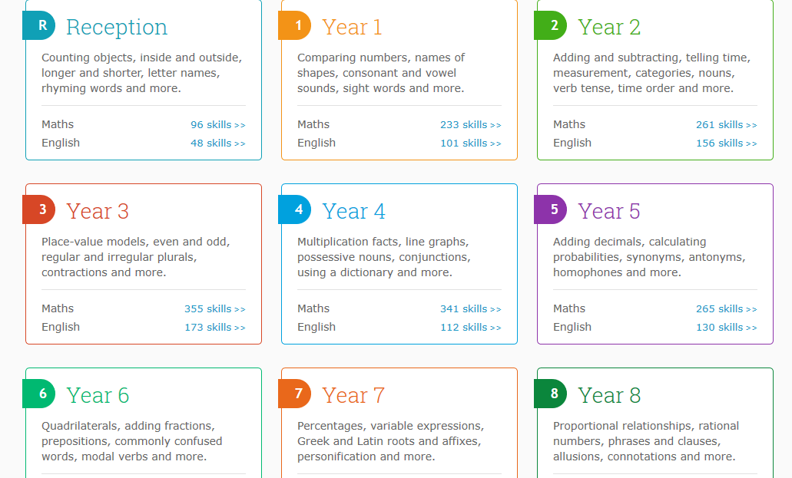 | IXL is linked directly with the National Curriculum. Maths skills are organised into categories and can be easily linked to your child’s in-school learning. IXL will track your child’s score, and the questions will automatically increase in difficulty as they improve!  This website can be used for 10 minutes a day, free of charge. There are also membership options to use the website to its full potential.
Topmarks | https://www.topmarks.co.uk  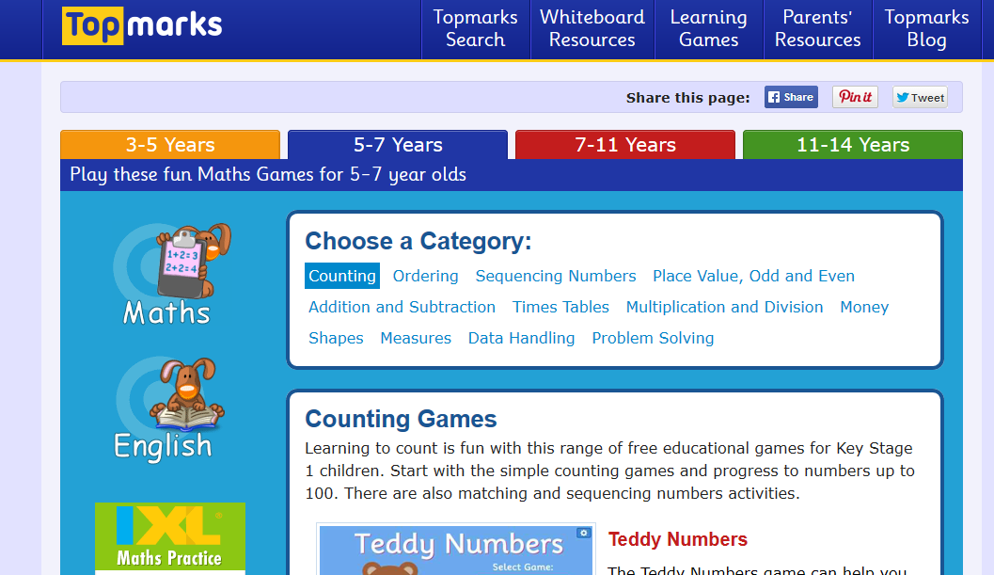 | Topmarks is a free to use website full of maths learning games. Choose your child’s age range and start playing.
BBC Bitesize | https://www.bbc.co.uk/bitesize  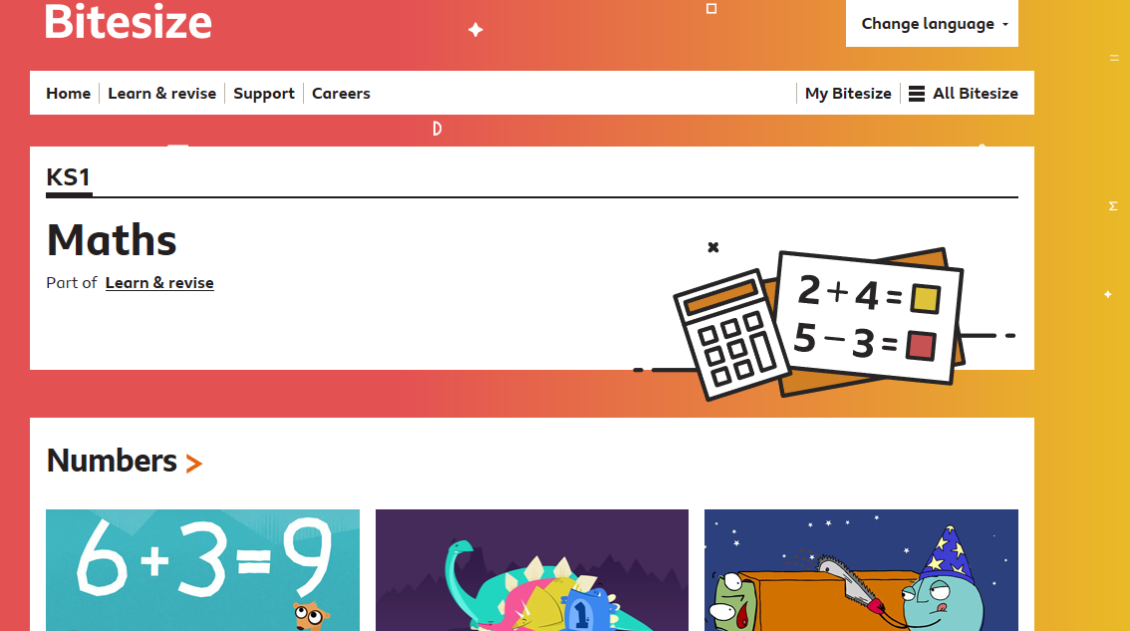 | BBC Bitesize is a fantastic website that is again, free to use. Select the age range that you require and revise the maths skill your child has been learning in school. There are engaging, helpful videos and short games to play.
Some useful apps:
Name of App | Price | Age Range
Times Table Rockstars | School subscription. Each child has own log in. | Year 2 – Year 6
IXL | Free and/or subscription | All ages
Maths Champions lite | Free  Full version available for £1.99 | From Year 3 – Year 6
Doodle Maths | Subscription | All ages
Sodoku | Free | Year 2 – Year 6
Maths, age 3-5  Maths, age 4-6 | Free | Reception – Year 2
2 For 2 | Free | Reception – Year 1

Some useful workbooks: (available online at Amazon)
Collins Maths Targeted Practice Workbook  (available for ALL year groups) | 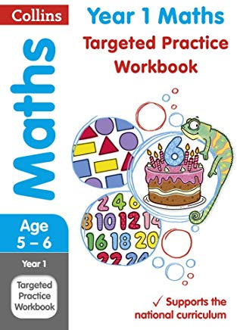 | Fully supports the National Curriculum
Letts Maths in 5 Minutes a Day (available for ALL year groups) | 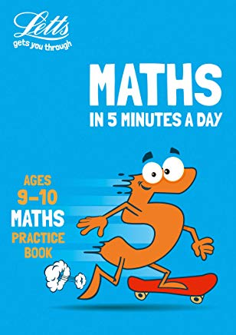 | Fully supports the National Curriculum
CGP KS1/KS2 Maths 10-Minute Weekly Workouts  (available for Years 1 - 6) | 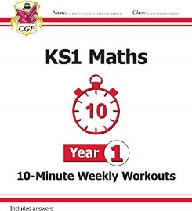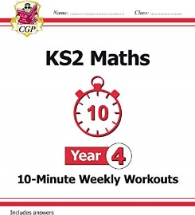 | Fully supports the National Curriculum
CGP Maths Targeted Question Book  (available for Years 1 - 6) | 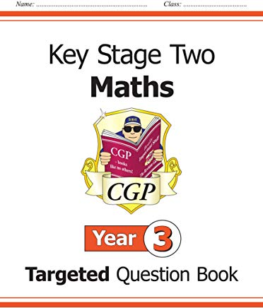 | Fully supports the National Curriculum

